ELECTROCHEMISTRY
-CHAPTER OVERVIEW & WEIGHTAGE
* Nature of the Chapter: Primarily numerical-based for both JEE Main and Advanced.
* JEE Main Weightage: Typically 1 to 2 questions per shift. Physical chemistry sections almost always include at least one problem from this chapter.
* Lecture Structure: The chapter is divided into four major segments:
1. Electrochemical Cells:
2. Electrolytic Cells & Electrolysis:
3. Conductance: Ion movement and resistance in solutions.
4. Batteries & Corrosion: Practical applications.

---
-Types of electrochemical cell :-
a) Galvanic/Voltaic
‣Converts chemical energy to electrical energy.
‣Spontaneous redox reaction occurs, ΔG = -ve
‣Anode(-ve), Cathode(+ve)
b) Electrolytic
‣Converts electrical energy to chemical energy.
‣Non-Spontaneous redox reaction occurs, ΔG = +ve
‣Anode(+ve), Cathode(-ve)

⦿ Anode : always oxidation
⦿ Cathode : always reduction
---
-Reversible and irreversible cell (voltaic) -
The main conditions of reversibility:
(i) The chemical reaction of the cell stops when an exactly equal opposing emf is applied.
(ii) The chemical reaction of the cell is reversed and the current flows in opposite direction when the opposing emf is slightly greater than that of the cell.
Any other cell which does not obey the above two conditions
is termed as irreversible.
---

INTUITION: THE ORIGIN OF ELECTRODE POTENTIAL
The "Electrode Potential" arises from the interaction between a metal rod and its own ionic solution.
⦿ The Assembly (Electrode): A metal rod dipped in its salt solution behaves as an assembly where electrons can enter or leave.
⦿ The Two Tendencies:
1. De-electronation (Oxidation): Metal atoms lose electrons and enter the solution as ions (M → Mⁿ⁺ + ne⁻). This makes the rod negatively charged and the solution positively charged. This assembly is the Anode.
2. Electronation (Reduction): Ions from the solution gain electrons and deposit as metal atoms (Mⁿ⁺ + ne⁻ → M). The rod becomes positively charged and the solution negatively charged. This assembly is the Cathode.
⦿ The Potential: The charge separation at the interface between the rod and the solution creates a potential difference known as Electrode Potential.
---
### GALVANIC (ELECTROCHEMICAL) CELLS
⦿ Working Principle: A cell is formed by connecting an assembly that wants to lose electrons (Anode) to one that wants to gain them (Cathode).
* Direction of Flow:
* Electrons: Flow from Anode to Cathode via the external circuit.
* Current: Flows from Cathode to Anode.

* The Daniell Cell (Zn-Cu Cell):
* Anode (Oxidation): Zn(s) → Zn²⁺(aq) + 2e⁻.
* Cathode (Reduction): Cu²⁺(aq) + 2e⁻ → Cu(s).
* Net Reaction: Zn(s) + Cu²⁺(aq) → Zn²⁺(aq) + Cu(s).

-THE SALT BRIDGE: CRITICAL FUNCTIONS
In a working cell, Zn²⁺ ions build up at the anode (positive density), and SO₄²⁻ remains at the cathode (negative density). This charge buildup eventually stops electron flow.
* Function 1: Completes the internal circuit.
* Function 2: Electrical Neutrality: It supplies ions to neutralize the excess charges (Cl⁻ to the anode, K⁺ to the cathode).
* Function 3: Minimizes LLJP: It reduces ”Liquid-Liquid Junction Potential”, which is a potential that develops at the interface of two solutions and opposes the cell's external EMF.

Selection Criteria for Salt Bridge Electrolyte (e.g., KCl):
* Equal Mobility: The cation (K⁺) and anion (Cl⁻) must have the same speed/transport number so they can solve the charge problem in both compartments simultaneously.
* Inertness: The salt should not react with the cell ions.
* Exception (The "Choking" Trap): “Do not” use KCl if the cell contains Ag⁺, Pb²⁺, Hg₂²⁺, or Tl⁺ ions. Cl⁻ will form a precipitate (e.g., AgCl), which "chokes" the mouth of the bridge and stops the cell. Use NH₄NO₃ or KNO₃ instead.

---

-IUPAC CELL REPRESENTATION
* General Rule: Anode (Left) || Cathode (Right).
* Phase Separation: A single vertical line (|) represents a phase boundary; a double line (||) represents the salt bridge.
* Same Phase: Use a comma to separate species in the same phase (e.g., Fe²⁺, Fe³⁺).

* Gas Electrode Representation (Very Important for JEE Advanced):
* Regardless of whether the gas is oxidized or reduced, the IUPAC rule is: Gas | Gas-ion (for Anode) and Gas-ion | Gas (for Cathode).
* Anode Example (Cl₂): Pt | Cl₂ | Cl⁻ (Even if Cl⁻ is losing electrons, the gas is written first).
* Cathode Example (Cl₂): Cl⁻ | Cl₂ | Pt.

# E_cell should be mentioned at the extreme right.
# Check terminals should be metallic.
# electron transfer in net reaction (n) is the electron that cancel out.

-STANDARD HYDROGEN ELECTRODE (SHE)
Theory & Physical Meaning
* The Reference Problem: Absolute electrode potential of a single electrode cannot be measured because a complete circuit is required for a potential difference to exist.
* The Solution: SHE is used as a ”primary reference electrode”. Its standard potential (oxidation or reduction) is ”arbitrarily” assigned as 0.0V at all temperatures.
Construction:
* Gas-Ion Assembly: H₂ gas is bubbled at 1 bar pressure into a solution containing 1 M H⁺ ions (e.g., HCl).
* Platinum Terminal: An inert Pt electrode acts as an electron carrier to bring electrons in or out of the solution phase.
Working: SHE can act as both Anode and Cathode depending on the electrode it is paired with.

Cell Notation
* As Anode (Oxidation): Pt(s) | H₂(g, 1 bar) | H⁺(aq, 1M).
* As Cathode (Reduction): H⁺(aq, 1M) | H₂(g, 1 bar) | Pt(s).
---
Standard conditions -
Concentration : 1M, Pressure : 1bar, Temperature(generally) : 25ᵒC / 298 K
# Ye yaad karne h-
At 298K -
• Eᵒ Zn/Zn^2+ = 0.76V
• Eᵒ Fe/Fe^2+ = 0.44V
• Eᵒ Cu2+/Cu = 0.34V
• Eᵒ Ag+/Ag = 0.80V
---
-ELECTROCHEMICAL SERIES (ECS)
Theory & Construction
* Origin: The series is created by pairing various electrodes with SHE under standard conditions (1M concentration, 1 bar, 298K).
* Measurement: The voltmeter reading of the cell (Eᵒ_{cell}) becomes the standard potential of the unknown electrode since Eᵒ_{SHE} = 0.
* Arrangement: Ions are arranged in ”increasing order of their Standard Reduction Potentials (SRP)”.

Interpretation & Applications
* Oxidizing and Reducing Power:
* Higher SRP: Indicates a greater tendency to get reduced. These species are Strong Oxidizing Agents (e.g., F₂ with Eᵒ = +2.87V).
* Lower SRP: Indicates a greater tendency to get oxidized. These species are Strong Reducing Agents (e.g., Li with Eᵒ = -3.05V).
* Metal Displacement: A metal with a lower SRP (higher up in the series) can displace a metal with a higher SRP from its salt solution.
* *Example:* Zinc can displace Copper from CuSO₄ because Eᵒ_{Zn} is lower than Eᵒ_{Cu}.
# Cathode - Electrode higher up in the series, high SRP, gets redused, are oxidising agent.
# Anode - Electrode lower in the series, low SRP, gets oxidised, are refucing agent.
* Reactivity with Acids: Metals placed above Hydrogen in the ECS (negative SRP) can liberate H₂ gas from dilute acids (e.g., Mg, Zn). Metals like Copper or Silver (positive SRP) cannot liberate H₂.
(alkali or alkaline earth metals) + cold water → H₂ + salt
Fe, Ni, Co, Pb, Sn + steam → H₂ + salt

# for the same electrode half-reaction, the standard reduction potential and the standard oxidation potential are equal in magnitude and opposite in sign.
Cu2+ + 2e → Cu, E∘_red​ = +0.34 V
Cu → Cu2+ + 2e, E∘_ox​ = −0.34 V
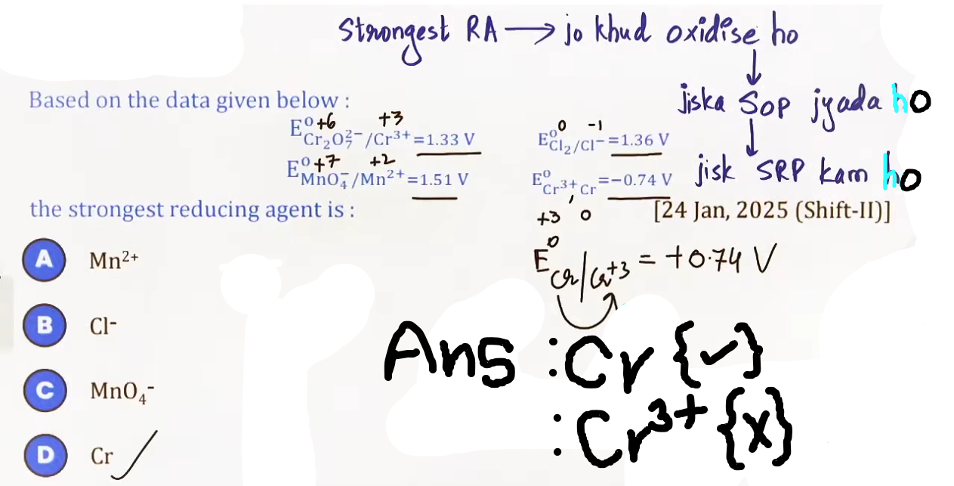
"Standard reduction potential = −Standard oxidation potential​"

# Li+(aq) +e → Li(s)
has the lowest SRP,
-3.04V, lala electron lena hi nahi chahta.
# F2(g) +2e → 2F-(aq)
has the highest SRP, 2.87V, lala electron li ke hi manega.
# jo jitna tagra oxidising agent (khud ka reduction) uska reduction potential utna jyada and vice-versa.

# A + B → ___
A ka oxidation aur B ka reduction tak hoga jab:- SOP_A > SOP_B OR SRP_A < SRP_B.
B ka oxidation aur A ka reduction tak hoga jab:- SOP_A < SOP_B OR SRP_A > SRP_B.
@ photo – question4.png
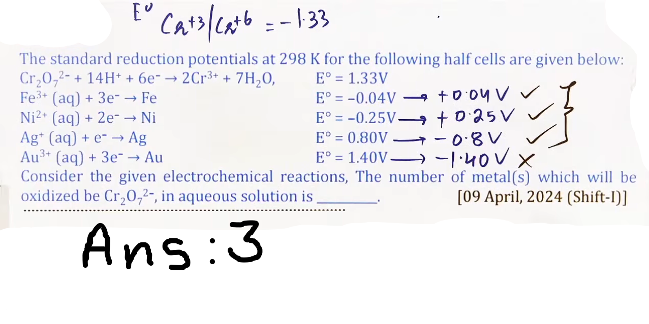
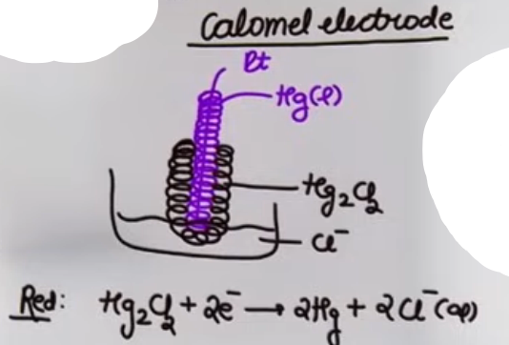
---
Different types of half cells -
• metal-metal ion half cell
• gas-ion half cell
• metal-insoluble salt-anion half cell OR metal-sparingly soluble salt-anion half cell.
e.g. Calomel electrode
@ photo – calomel.png

---

-STANDARD EMF (Eᵒ_{cell})

Definition & Derivation
* EMF: Electromotive Force is the potential difference between two electrodes when no current is drawn from the cell.
* Master Formula:
> Eᵒ_{cell} = Eᵒ_{SRP(Cathode)} - Eᵒ_{SRP(Anode)}.
* Constraint: Both values must be in ”Standard Reduction Potential (SRP)”. If a problem gives an Oxidation Potential, it must be reversed in sign first.

Thermodynamic Relations
* Work & Free Energy:
ΔGᵒ_{cell} = -nFEᵒ_{cell}.
ΔGᵒ_{electrode} = -nFEᵒ_{electrode}.
where, F ( Faraday constant ) = 96500 C/mol

# 1 Farad = the charge on one mole of electrons:
e times N_a = (1.6x10⁻19 C ) x (6.023x10^23 mol⁻) = 96500 C/mol

#@physics m tha V = W/q, work done per unit charge in known as potential toh wo hi hum yahan use karenge ΔG matlab work done(ΔG = W) nikalne k liye toh, W = Vq, total moles of e transfered in reaction is the 'n' and the total charge(q) will be nF aur V toh EMF h hi toh,
W = Vq, ΔG = nF(Eᵒ) hoga aur -ve sign convention consistent karne k liye kiya matlab spontaneous reaction k liye ΔG = -ve and Eᵒ should be +ve toh equation m negative laga diya
ΔG = -nF(Eᵒ) @#

* Spontaneity: A cell reaction is spontaneous if Eᵒ_{cell} is positive, which results in a negative ΔGᵒ.
# if a redox rexn: aA + bB → cC + dD is non-spontaneous → E = -ve → ΔG = +ve
then the redon rexn:cC + dD → aA + bB will be spontaneous→ E = +ve→ ΔG = -ve

# EMF(Eᵒ_{cell}) is an intensive property (not dependent on mass or size). So we “can not” add or substract E∘ values of two reaction to calculate E∘ of the reaction.
# ΔG is an intensive property, we can add or substract ΔG values of two reaction to calculate ΔG of the reaction.
#@( matlab agar hum ek reaction banaye do reaction ko add karke to hum nayi reaction ka EMF un do reaction ka sum nahi kah sakte par ΔG kar sakte h )@#
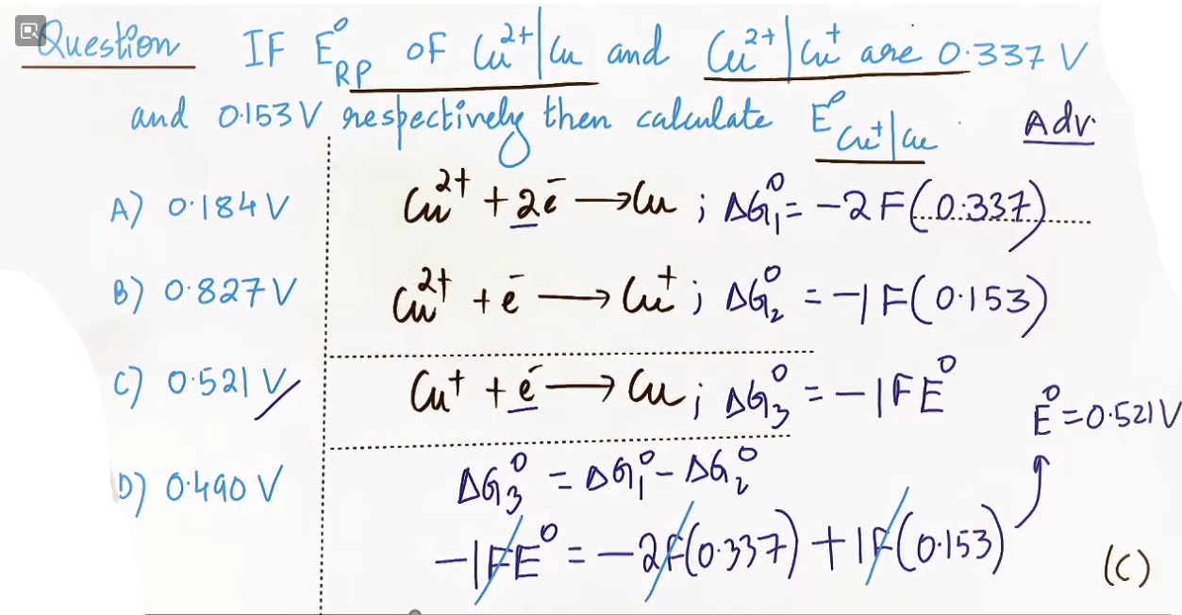
JEE ADVANCED INSIGHTS
* The Intensive Property Trap: Eᵒ is an intensive property (independent of mass/size) and cannot be added or subtracted directly when combining half-reactions.
* ΔG Method for Unknown Potentials: To find the Eᵒ for a new half-reaction from two known ones, you must convert the Eᵒ values to ΔGᵒ (which is extensive/additive), combine them, and then convert back to Eᵒ.
* *Example:* Calculating Fe³⁺ \to Fe²⁺ potential from Fe³⁺ \to Fe and Fe²⁺ \to Fe.
* Equilibrium Link: At equilibrium, E_{cell} = 0. The standard potential relates to the equilibrium constant (K_{eq}) as follows:
> Eᵒ_{cell} = (0.0591/n) log(K_{eq}) (at 298K). {from nerst eqn}
---
IMPORTANT RESULTS TO MEMORIZE

* SHE Potential: Always 0.0V.
* Daniell Cell: Zn/Cu system, Eᵒ_{cell} = 1.1V.
* Hydrogen Potential & pH: E_{H⁺/H₂} = -0.059 times pH.
* n-factor in Net Cell: The number of electrons that ”cancel out” when adding the Anode and Cathode half-reactions.
---
COMMON MISTAKES
* Sign Conventions: Mixing SOP and SRP in the EMF formula. Always use Eᵒ_{red(Cathode)} - Eᵒ_{red(Anode)}.
* Adding Voltages: Trying to add Eᵒ of two half-reactions to get a third half-reaction potential without using ΔG.
* Hydrogen Gas Notation: Forgetting that for a gas electrode, the gas must be written first in an Anode representation (H₂ | H⁺) and last in a Cathode representation (H⁺ | H₂ | Pt).
--------------------------------------------------------------------
NERNST EQUATION FOCUS
* Core Idea: Standard electrode potentials (Eᵒ) are only valid under standard conditions (1M concentration, 1 bar pressure, 298K). The Nernst Equation is the mathematical bridge used to calculate the actual EMF (E_{cell}) or electrode potential (E) when conditions deviate from standard.
* Important Subtopics:
* Nernst Equation for half-cells and full cells.
* Relationship with the Equilibrium Constant (K_{eq}).
* Link between Hydrogen Electrode potential and pH.
* Nernst Equation links with Kₛₚ and Solubility.
* Weightage Relevance: Extremely High. This is the most frequently asked numerical section in JEE Main and Advanced.
* Prerequisites: Thermodynamics (ΔG), Chemical Equilibrium (Q and K_{eq}), and balancing redox reactions (n-factor).
---
THEORY NOTES (VERY DETAILED)

A. Definition and Physical Meaning
The Nernst Equation relates the electrode potential of an electrochemical cell to the standard electrode potential, temperature, and activities (often approximated by concentrations and pressures) of the chemical species undergoing oxidation and reduction.
* Intuition: If you increase the concentration of reactants, the "pressure" to form products increases, making the cell potential higher. Conversely, if products build up, the potential drops.

B. Derivation (Step-by-Step)
1. From Thermodynamics, the change in Gibbs Free Energy is:
ΔG = ΔGᵒ + RT[ln(Q)].
2. Substitute the electrochemical relations ΔG = -nFE_{cell} and ΔGᵒ = -nFEᵒ_{cell}.
3. -nFE_{cell} = -nFEᵒ_{cell} + RT ln Q.
4. Divide the entire equation by -nF:
E_{cell} = Eᵒ_{cell} – (RT/nF)ln Q.
5. At 298 K, convert the natural log (ln) to base 10 log (\log₁₀) using the factor 2.303:
E_{cell} = Eᵒ_{cell} -(0.0591/n)log₁₀(Q).

# log(a/b) = -log(b/a)
# ΔG∘ = -nFE∘
# ΔG∘ = -RT ln(K_eq) at equillibrium

C. Variables and Units
* E_{cell}: Actual cell potential (Volts).
* Eᵒ_{cell}: Standard cell potential (Eᵒ_{cathode} - Eᵒ_{anode}).
* n: Number of moles of electrons transferred in the balanced net reaction.
* F: Faraday's constant (≅ 96500 C/mol).
* R: Real Gas constant (≅ 8.314).
* Q: Reaction Quotient (Concentration of Products / Concentration of Reactants, raised to their stoichiometric coefficients).

D. Important Graphs
* E_{cell} vs. \log Q: A straight line with a negative slope.
* Slope: -0.0591/n (for log₁₀) or -RT/nF (for ln).
@ photo – graph.png
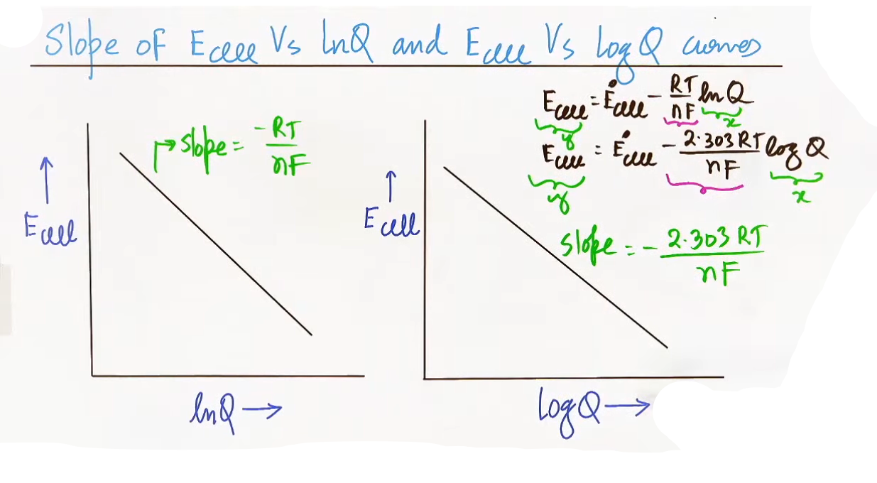
* Intercept: Eᵒ_{cell}.
* As Time Passes: As a cell discharges, Q increases. E_{cathode} decreases and E_{anode} increases until they become equal (E_{cell} = 0), reaching equilibrium.
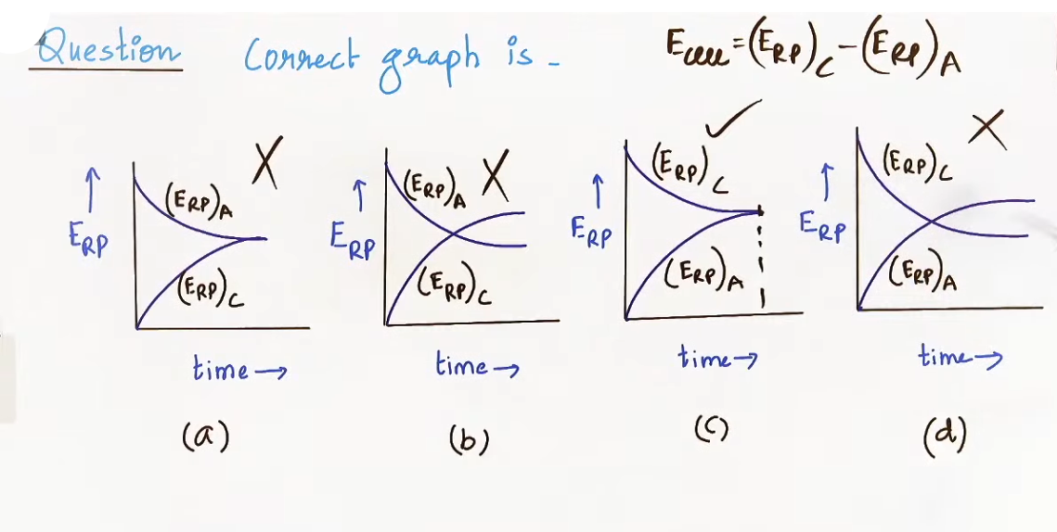
ALL IMPORTANT FORMULAS
Formula | Context | Conditions/Validity
E = Eᵒ - (0.0591/n)log Q | General Nernst Eq. | Valid at 298 K.
log K_{eq} = nEᵒ/0.0591 | Equilibrium | At equilibrium (E_{cell} = 0).
E_{H⁺/H₂} = (-0.0591)(pH) | Hydrogen Electrode | Standard Reduction Potential at 298K.
E_{H₂/H⁺} = (+0.0591)(pH) | Hydrogen Electrode | Standard Oxidation Potential at 298K.
ΔG = -nFE_{cell} | Work and Potential | Relates actual energy to actual EMF.
JEE ADVANCED INSIGHTS
* The Concentration Cell Trap: In cells where the electrodes are the same material but concentrations differ (Eᵒ_{cell} = 0), the potential is driven purely by log(C_{anode}/C_{cathode}).
* Insoluble Salt Link: JEE Advanced often hides the concentration term (Q) by giving a Solubility Product (Kₛₚ). You must use Kₛₚ = [Mⁿ⁺][Xⁿ⁻] to find the ion concentration before plugging it into the Nernst Equation.
* Stoichiometry Power: When n is balanced (e.g., n=6 for Al/Mg cell), ensure Q includes coefficients as powers.
* Temperature Coefficient: The relation ΔS = nF(dE/dT) can be used to see how E_{cell} changes with temperature.
PROBLEM-SOLVING FRAMEWORK
1. Write Half-Reactions: Identify oxidation (anode) and reduction (cathode).
2. Balance Electrons (n): Multiply reactions so electrons cancel. This common value is your n.
3. Find Eᵒ_{cell}: Use Eᵒ_{red(cathode)} - Eᵒ_{red(anode)}.
4. Determine Q: Write the expression for Q using the net balanced equation. “Ignore solids and pure liquids”.
5. Substitute and Solve: Plug Eᵒ, n and Q into E = Eᵒ - (0.0591/n)log Q.
---
PYQ-STYLE THINKING
* The "Nernst-pH" Mix: JEE frequently asks for the potential of a hydrogen electrode dipped in a solution of a specific pH.
* The "Log-Zero" Trap: Students often confuse E_{cell} = 0 (equilibrium) with Eᵒ_{cell} = 0 (concentration cell).
* Non-Standard T: If T ≠ 298K, you “cannot” use 0.0591. You must use the full (2.303 RT/nF).
---
IMPORTANT RESULTS TO MEMORIZE
* At Equilibrium: E_{cell} = 0; Q = K_{eq}.
* Standard Result: For the Daniell Cell (Zn/Cu), Eᵒ = 1.1V.
* Slope of E vs. log Q: Always negative; magnitude depends on n.
---
ADVANCED LEVEL CONCEPT CONNECTIONS
* Ionic Equilibrium: Using pH = -log[H⁺] or pOH = -log[OH⁻] to find concentrations for Nernst problems.
* Thermodynamics: Linking E_{cell} to work: W_{max} = ΔG = -nFE_{cell}.
* Kinetics: Overpotential/Overvoltage (like in Cl₂ evolution) explains why Nernst values sometimes differ from experimental results.
* The Overvoltage Trap: In aqueous NaCl, the SOP of H₂O is higher than Cl⁻, yet Cl₂ is evolved. This is because the oxidation of water to O₂ is kinetically slow and requires an additional "overvoltage".
* Concentrated vs. Dilute H₂SO₄:
* Dilute: Water oxidizes to O₂.
* Concentrated: SO₄²⁻ is forced to oxidize to peroxodisulphuric acid (H₂S₂O₈).
* Active Anode Competition: If you electrolyze CuSO₄ using copper electrodes, the anode itself dissolves (Cu \to Cu²⁺) because Cu oxidation potential is higher than H₂O. The concentration of Cu²⁺ in solution remains constant.
* IMPORTANT RESULTS TO MEMORIZE
* Molten NaCl: Cathode (Na), Anode (Cl₂).
* Aqueous NaCl: Cathode (H₂ from water), Anode (Cl₂ due to overvoltage).
* Aqueous CuSO₄ (Inert Pt): Cathode (Cu), Anode (O₂ from water).
* Aqueous AgNO₃ (Active Ag): Cathode (Ag deposits), Anode (Ag dissolves).
* Equivalents Rule: No matter the substance, 1 Faraday of charge always deposits 1 equivalent of any substance.
---
REVISION NOTES
* Nernst Purpose: Find E when C ≠ 1M.
* Standard Eq:
E_{cell} = Eᵒ_{cell} - (RT/nF)ln(Q) ,
E = Eᵒ – (0.0591/n) log Q.
* Equilibrium: E = 0 and Eᵒ = (0.0591/n)log K_{eq}.
* H-electrode: E = -0.0591 \times pH.
--------------------------------------------------------------------
CHAPTER OVERVIEW (ADVANCED ELECTRODES & THERMAL PROPERTIES)

not so imp :(

* Core Idea: This section moves beyond standard metal-ion electrodes to explore complex assemblies (Insoluble Salt and Redox electrodes) and the relationship between a cell’s electrical output and its thermodynamic (thermal) environment.
* Important Subtopics:
* Classification of electrodes (Redox, Gas, Metal-Ion).
* Advanced derivation of Metal-Insoluble Salt Anion Electrode potentials.
* Relationship between Temperature Coefficient (dE/dT) and Entropy (ΔS)/Enthalpy (ΔH).
* Weightage Relevance: High for JEE Advanced. These topics are often used in "paragraph-type" or multi-concept questions linked with Ionic Equilibrium (Kₛₚ).
* Prerequisites: Nernst Equation, Gibbs Free Energy (ΔG), and basics of Solubility Product (Kₛₚ).

---
THEORY NOTES (VERY DETAILED)

A. Types of Electrodes
The lecture classifies electrodes into four primary assemblies based on their physical state and chemical nature:
1. Metal-Metal Ion Electrode: The standard assembly where a metal rod is dipped in its own cation solution (e.g., Zn/Zn²⁺).
2. Gas-Gas Ion Electrode: A gas is bubbled over an inert terminal (Pt) in a solution of its ions (e.g., SHE or Cl₂/Cl⁻).
3. Redox Electrode: A single element exists in two different oxidation states in the same solution. An inert Pt wire facilitates electron transfer (e.g., Fe²⁺, Fe³⁺/Pt).
4. Metal-Insoluble Salt Anion Electrode: A metal rod coated with its own insoluble salt, dipped in a solution containing the salt's anion.

B. Metal-Insoluble Salt Anion Electrode (Detailed)
* Construction: Metal (M) + Paste of Insoluble Salt (MX) + Solution containing Anion (X⁻).
* Physical Meaning: This electrode's potential is governed by the equilibrium between the metal and the tiny amount of metal ions provided by the insoluble salt.
* Standard Example (Calomel Electrode): Represented as Hg(l) | Hg₂Cl₂(s) | Cl⁻(aq).
* Half-Cell Reactions:
* As Cathode (Reduction): AgCl(s) + e⁻ → Ag(s) + Cl⁻(aq).
* As Anode (Oxidation): Ag(s) + Cl⁻(aq) → AgCl(s) + e⁻.
* Derivation of Potential (Eᵒ via Kₛₚ):
The potential of this electrode is linked to the standard reduction potential of the metal and the solubility product (Kₛₚ) of the salt:
Eᵒ_{X⁻|MX|M} = Eᵒ_{Mⁿ⁺|M} + (0.059/n) log(Kₛₚ).
Eᵒ_{X⁻|MX|M} = Eᵒ_{Mⁿ⁺|M} + (RT/nF) log(Kₛₚ).

Thermal Properties of Cells
* The Temperature Coefficient (dE/dT): This represents how the cell potential changes as temperature changes at constant pressure.
* Entropy (ΔS): Directly proportional to the temperature coefficient.
ΔS = nF (dE/dT) OR ΔS = nF (∂E/∂T)P
* Enthalpy (ΔH): Derived using the Gibbs-Helmholtz relation (ΔH = ΔG + TΔS).
ΔH = -nF(E_cell) + nFT(dE/dT) OR ΔH = −nFE + nFT(∂E/∂T)P
OR ΔH = -nF [E – T(dE/dT)] .

* Physical Intuition: If dE/dT is positive, the cell potential increases with temperature, implying the cell reaction is entropy-driven.

ALL IMPORTANT FORMULAS
Formula | Context | Meaning of Variables
Eᵒ_{salt} = Eᵒ_{metal} + (0.059/n) log Kₛₚ | Insoluble Salt Potentials | Eᵒ_{metal}: SRP of metal;  Kₛₚ: Solubility Product.
ΔS = nF(dE/dT)P | Entropy of Cell | dE/dT: Temp. Coefficient (V/K).
ΔH = -nFE + nFT(dE/dT)_P | Enthalpy of Cell | E: Actual cell EMF.
ΔG = -nFE | General Work | Relation between free energy and EMF.

JEE ADVANCED INSIGHTS
* The Reference Electrode Preference: For an electrode to be a good "reference," it should have the lowest possible Temperature Coefficient (dE/dT). This ensures its potential remains constant even if the laboratory temperature fluctuates.
* Calomel Categorization: JEE Advanced often tests the categorization of electrodes. Always remember that the Calomel electrode is a “Metal-Insoluble Salt Anion electrode”, NOT a simple metal-ion or redox electrode.
* Kₛₚ Hidden Link: If a question gives the potential of a metal-metal ion electrode and asks for the potential of the metal-insoluble salt version, it is testing your ability to apply the log(Kₛₚ) correction term.
---
IMPORTANT RESULTS TO MEMORIZE
* Ag/AgCl
Cathode Rxn: AgCl + e⁻ → Ag + Cl⁻
Anion Rxn: Ag + Cl⁻ → AgCl + e⁻ → .
* Temperature dependence: E_{cell} is dependent on temperature (via dE/dT), but Eᵒ_{cell} is NOT dependent on pressure.
* Reference standard: Standard Hydrogen Electrode (SHE) has Eᵒ = 0 at ALL temperatures.
--------------------------------------------------------------------
CHAPTER OVERVIEW (ELECTROLYSIS FOCUS)
* Core Idea: Electrolytic cells use “external electrical energy” to drive a “non-spontaneous” chemical reaction (ΔG > 0). This is essentially the reverse of a Galvanic cell, often occurring during the "charging" phase of a battery.
* Important Subtopics:
* Qualitative Aspects: Predicting products at the cathode and anode using preferential discharge rules.
* Quantitative Aspects: Faraday’s First and Second Laws of Electrolysis.
* Practical Applications: Electroplating, metal purification, and "charging" mechanisms.
* Weightage Relevance: High frequency for numerical problems in JEE Main; conceptual "product prediction" traps are common in JEE Advanced.
* Prerequisites: Redox balancing, knowledge of the Electrochemical Series (SRP values), and basic circuit concepts.
---
THEORY NOTES (VERY DETAILED)

A. Electrolytic Cells vs. Galvanic Cells
* Definition: An electrolytic cell consists of two electrodes dipped in an electrolytic solution or melt, connected to an external DC source.
* Intuition: While a Galvanic cell works because a reaction “wants” to happen, an electrolytic cell works because we “force” a reaction to happen.
* Polarity Shift:
* Anode: Connected to the positive terminal of the source; site of oxidation.
* Cathode: Connected to the negative terminal; site of reduction.
* The Charging Concept: If an external EMF (E_{ext}) greater than the cell's standard EMF (Eᵒ_{cell}) is applied, the spontaneous flow of electrons reverses. For example, in a Daniel cell (Zn-Cu), when E_{ext} > 1.1 V, Zn²⁺ reduces at the cathode and Cu oxidizes at the anode—the exact opposite of normal discharge.

B. Principles of Electrolysis (Qualitative)
Electrolysis - The process of decomposition of an electrolyte on passing electricity or electrical current through it's aq solution or molten state. The cell used for this process is called an electrolytic cell.

Predicting which ion will deposit or liberate at an electrode depends on three primary factors:
1. Nature of Electrolyte: Whether the substance is molten (no water competition) or aqueous (competition with H₂O).
2. Nature of Electrode:
* Inert Electrodes (Pt, C, Pd): Do not participate in the reaction; they only act as electron carriers.
* Active Electrodes (Cu, Ag, Ni, Zn): The electrode itself can undergo oxidation at the anode.
3. Overpotential (Bubble Voltage): Sometimes the kinetically preferred product differs from the thermodynamically predicted one (e.g., Cl₂ vs O₂ at the anode).

C. Preferential Discharge Rules
When multiple species can react, the following rules apply:
* At the Cathode (Reduction):
* Cations with “higher SRP” (more positive) reduce first.
* The Water Rule: Ions from Group 1 (Li, Na, K) and Group 2 (Mg, Ca) have lower SRP than water (-0.83 V). Therefore, in aqueous solutions of these salts, H₂ gas is produced from water reduction instead of the metal.
* Active metal ions like Cu²⁺, Ag⁺, Au³⁺, Hg₂²⁺, and Pt²⁺ reduce “before” water.

* At the Anode (Oxidation):
* Anions with “higher SOP” (lower SRP) oxidize first.
* Halide Rule: If Cl⁻, Br⁻, or I⁻ are present with water, the halogens (Cl₂, Br₂, I₂) are produced.
* Oxygen Rule: F⁻, SO₄^{2-}, NO₃⁻, PO₄^{3-}, and OH⁻ do not oxidize in the presence of water. Instead, “water oxidizes to produce O₂ gas” (Eᵒ_{ox} = -1.23 V).

# agar SO4^2- ko oxidise hona hi h toh -
2SO4^2- → S2O8^2- +2e

# Cations having more reduction potential, reduce first at cathode.
# Anions having more oxidation potential, oxidise first at anode.
# Water oxidises to form O₂ gas and 4H+ ions, SOP of H₂O = -1.23V
# Water reduces to form H₂ gas and O- ions, SRP of H₂O = -0.83V

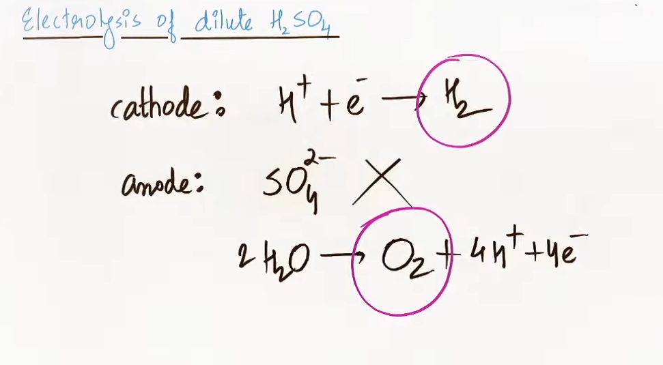
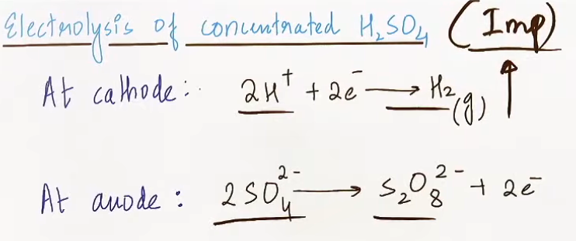

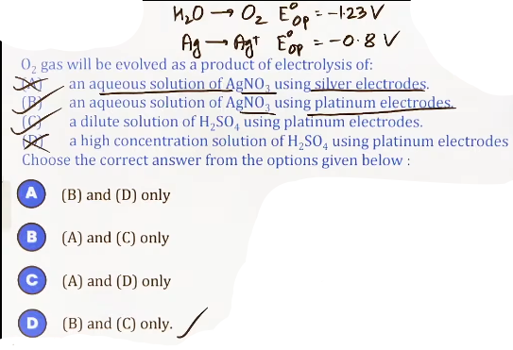
---

(FARADAY’S LAWS OF ELECTROLYSIS)
* Core Idea: While the qualitative aspect of electrolysis predicts *what* is produced, Faraday’s laws govern the quantitative aspect—specifically, “how much” of a substance is deposited or liberated at an electrode.
* Important Subtopics:
* Faraday’s First Law: Relationship between mass and charge.
* Faraday’s Second Law: Comparing substances in series.
* The Faraday Constant (F): Charge of 1 mole of electrons.
* Advanced Applications: Electroplating and concentration changes during electrolysis.
* Weightage Relevance: Very high for JEE Main (direct numericals) and moderate for JEE Advanced (integrated with Nernst or kinetics).
* Prerequisites: Redox balancing (n-factor/equivalent weight calculations), basics of current and charge (Q = It).

---
THEORY NOTES (VERY DETAILED)

A. Faraday’s First Law of Electrolysis
* Definition: The mass (W) of any substance deposited or liberated at any electrode is directly proportional to the quantity of electricity (Q) passed through the electrolyte.
* Intuition: Think of electrons as "couriers." Each electron carries a specific amount of charge and performs a specific amount of chemical "work." The more electrons (charge) you push through the solution, the more ions are forced to reduce or oxidize.
* Derivation (Step-by-Step):
1. W ∝ Q.
2. Substitute Q = It (where I is current in Amps, t is time in seconds): W ∝ It.
3. Introduce the constant Z (Electrochemical Equivalent): W = ZIt.
4. Since 1 Faraday (96500 C) deposits 1 equivalent weight (E) of a substance: E = (Z)96500.
5. Therefore, Z = E / 96500.
6. Final Formula: W = EIt/96500.
for gases: V = (Vₑ)It/96500
V= Volume at STP
Vₑ = Equivalent volume
* Units: W in grams, I in Amperes, t must be in seconds.
B. Faraday’s Second Law of Electrolysis
* Definition: When the same quantity of electricity is passed through different electrolytes connected in series, the masses of the substances produced are proportional to their equivalent weights.
* Intuition: Imagine a chain of different cells. The same "stream" of electrons flows through all of them. Each mole of electrons will always deposit exactly one equivalent of *any* substance, regardless of the ion's identity.
* Derivation:
1. From the 1st Law: W₁ = (E₁ × Q) / 96500 and W₂ = (E₂ × Q) / 96500.
2. Divide them: W₁/W₂ = E₁/E₂ or W₁/E₁ = W₂/E₂.
3. This implies that the “number of equivalents” deposited in every cell in series is identical.

# equivalents of substances deposited at cathode = equivalents of substances liberated at anode

C. The Faraday Constant (F)
* Physical Meaning: It is the total charge carried by “one mole of electrons”.
* Calculation: F = N_A x e ≅ (6.022 x 10²³) x (1.6 x 10⁻¹⁹) ≅ 96500 C/mol.
* Shortcut: 1 Faraday (1 F) of charge always deposits 1 equivalent of any substance.

---
Most imp-
## Q = (n x n_f) F
n = given mass/molar mass # number of moles
n_f = n-factor, molar mass/W_eq, {W_eq = E = equivalent mass}
## n_f m toh e jo transfer ho rahe h vo le leta hu ;)
# n-factor = Valency (for many simple salts)
## E times n_f = molar mass
# Equivalent Weight = Molar Mass ÷ n-factor

---
ALL IMPORTANT FORMULAS
Formula | Variables | Meaning/Usage
W = EIt/F | E = Atomic Weight / n-factor | Calculate mass deposited at standard 100% efficiency.
W₁/E₁ = W₂/E₂ | W₁, W₂ : masses;  E₁, E₂ : Eq. weights | Used for cells connected in series.
Ahd = (EIt)/F | A: Area, h: thickness, d: density | Electroplating Formula: Relates thickness of coating to current.
Equivalents (Eq) = Q/F = Moles × n-factor | Q in Coulombs, F = 96500 | Quick conversion between charge, equivalents, and moles.
% Efficiency = (W_actual / W_theoretical) × 100 | W_{theo} from Faraday's Law | Used when some current is "wasted" in side reactions.

JEE ADVANCED INSIGHTS
* The "Coupled" Concept (Faraday + Nernst): Advanced problems often ask for the “new EMF” of a cell after electrolysis has occurred for a certain time. You must use Faraday's Law to find the change in ion concentration (M_{new}), then plug that into the Nernst Equation.
* Gas Volume at STP: For gases like H₂ or O₂, the mass W is often converted to Volume. 1 Faraday produces 11.2 L of H₂ and 5.6 L of O₂ at STP (1 equivalent of gas).
* Varying Oxidation States: Be careful with ions like Fe (can go to +2 or +3). The n-factor depends on the specific reaction provided in the problem.

PROBLEM-SOLVING FRAMEWORK
Type 1: Mass or Time Calculation
1. Identify the ion and write the reduction/oxidation half-reaction (e.g., Al³⁺ + 3e⁻ → Al).
2. Determine the n-factor (the number of electrons transferred).
3. Calculate Equivalent Weight (E = Atomic Weight/n).
4. Check units: Ensure time is in seconds.
5. Plug into W = EIt / 96500.
Type 2: Electroplating (Thickness)
1. Use the A x h x d formula.
2. Crucial Unit Check: Area is usually in cm^2 and density in g/cm³; ensure thickness h is also in cm before converting to mm or other unit.
---
COMMON MISTAKES
* n-factor Confusion: Using the atomic weight of a diatomic gas (like Cl₂) but using the n-factor for a single atom (n=1) instead of the molecule (n=2).
* Efficiency Neglect: Forgetting to multiply by percentage efficiency when calculating the actual yield.
---
REVISION NOTES (ULTRA-SHORT)
* 1 Faraday = 96500 C = 1 mole electrons = 1 equivalent.
* Main Formula: W = (EIt/96500).
* Series: Equivalents of A = Equivalents of B = Equivalents of C.
* Cathode Equivalents = Anode Equivalents: The amount of product at both electrodes is linked by charge.
--------------------------------------------------------------------------------
CHAPTER OVERVIEW (CONDUCTANCE FOCUS)
* Core Idea: While the first part of electrochemistry deals with electron flow through wires (metallic), this section focuses on the movement of “ions through solutions” (electrolytic conductance).
# jaise physics m wire ka resistance nikalte h waise yahan electrolytic solution ke resistivity nikalne h, analogous h dono.
* Important Subtopics:
* Basics: Resistance, Conductivity (κ), and Cell Constant (G*).
* Molar Conductivity (Λₘ): Concentration-dependent conductance.
* Variation with Dilution: Debye-Hückel-Onsager equation and the difference between strong/weak electrolytes.
* Kohlrausch’s Law: Ionic conductivities at infinite dilution.
* Weightage Relevance: High for JEE Main (direct numericals on Λₘ and ∝) and Advanced (conductometric titrations and complex graphical analysis).
* Prerequisites: Basic electrical concepts (V=IR), Molarity/Normality, and Ionic Equilibrium (Degree of dissociation ∝).
---
THEORY NOTES (VERY DETAILED)
A. Conductance Basics
* Physical Meaning: Electrolytic solutions behave like "conductive wires" where the charge carriers are ions instead of free electrons.
* Resistance (R): R = ρ l/A. In chemistry, 'l' is the distance between electrodes and 'A' is the cross-sectional area of the electrodes.
* Conductivity / Specific Conductance (κ - Kappa):
* Definition: The reciprocal of resistivity (ρ). It is the conductance of 1 mL (1 cm³) of electrolytic solution.
* Derivation: Since R = ρ l/A, then 1/R = (1/ρ)(A/l). Substituting G = 1/R and κ = 1/ρ, we get G = κ(A/l) or κ = G x l/A.
* Cell Constant (G*): Represented as l/A. It is a fixed geometric property of a specific conductivity cell.
* Formula: κ = (G*)(G).
Units -
κ : ohm⁻¹ cm⁻¹
G : ohm⁻¹ OR mho OR seimens(S)
G* : cm⁻¹

# specific conductance (κ) of a solution is defined as the conductance offered by 1 cm³ of electrolytic solution.
B. Molar Conductivity (Λₘ, λₘ)
* Definition: The conductance of all ions produced by “1 mole” of electrolyte dissolved in V mL of solution.
* Intuition: If κ is the conductance per mL, and V is the volume (in mL) containing 1 mole, then Λₘ = κ x V.
* Derivation (Step-by-Step):
1. Molarity (M) = moles / Volume{in Litre).
2. For 1 mole, V(L) = 1/M.
3. Convert to mL: V(mL) = 1000/M.
4. Since Λₘ = κ x V(mL), then Λₘ = κ(1000)/M.
# Λₘ = κ times V
# Λₘ = κ(1000)/M
Unit : S cm^2 mol⁻1

B. Equivalent conductivity or Equivalent conductance (Λₑq, λₑq):-
It is defined as the conductance of all the ions produced by one gram equivalent of the eletrolyte in the given volume of solution.
Λₑq = κ times V
V = Volume of solution containing 1 gram equivalent of electrolyte.
If concentration of solution is N-gram equivalent per litre then
Λₑq = κ(1000)/N, {N = normality}

# molar conductance m neeche M aur eq conductance n neeche N
# Λₘ/Λₑq = [κ(1000)/M]/[κ(1000)/N] = N/M = n-factor

C. Factors Affecting Conductance
1. Inter-ionic Attraction: Stronger attractions between ions (solute-solute) decrease mobility and conductance.
2. Solvent Polarity: Solvents with high dielectric constants (like water) dissociate electrolytes better, increasing conductance.
3. Viscosity: High viscosity (solvent-solvent friction) restricts ion movement, decreasing conductance.
4. Temperature: Increasing T increases the kinetic energy of ions, decreasing attractions and viscosity, which “increases conductance”.
5. Hydration Size: Smaller ions in the periodic table often have “larger hydrated radii” (e.g., Li⁺ vs. K⁺). A larger hydrated shell makes the ion "heavier" and slower, decreasing its conductance.
6. Dilution:
a) On increasing the dilution conductance (G) increases-
For strong electrolyte on dilution interionic force of attraction decreases and therefore conductance increases. (G)
For weak electrolyte with dilution degree of dissociation (∝) increases and therefore conductance increases. (G)
b) On dilution specific conductance decreases because on dilution number of ions in 1 mL solution decreases. (κ)
c) On dilution equivalent and molar conductance increases because with dilution normality or molarity decreases. (Λₘ, Λₑq)

# for increase in dilution, Λₑq, increases, Λₘ increases, G increases, κ decreases
---
ALL IMPORTANT FORMULAS
Formula | Variables | When to Use | Common Mistake
κ = G*/R | κ: Conductivity; G*: Cell Constant; R: Resistance | To find κ or G* from resistance data. | Confusing Conductance (G) with Conductivity (κ).
Λₘ = κ(1000)/M | M: Molarity | To find molar conductivity. | Forgetting the "1000" factor when units are in cm.
(Λₘ)(Λₑq) = n-factor | Λₑq: Eq. Conductivity | To convert between Molar and Equivalent conductivity. | Using the wrong n-factor for salts (e.g., Al₂(SO₄)₃ is 6).
Λₘ = Λᵒₘ - b√C | b: constant; C: concentration | Debye-Hückel-Onsager Eq. for strong electrolytes. | Applying this straight-line equation to weak electrolytes.
∝ = (Λₘ)/(Λᵒₘ) | ∝: Degree of dissociation | To find how much a weak electrolyte has dissociated. | Using it for strong electrolytes (where ∝ ≅ 1).

# Debye Huckel Onsager eqn - Applicable only for strong electrolytes.
---

JEE ADVANCED INSIGHTS
* The H⁺ and OH⁻ Jump Mechanism: Conductance of H⁺ and OH⁻ is exceptionally high because they don't just "travel"; they "jump" through the hydrogen-bonded water network (Grotthuss mechanism), making them faster than any other ion.
* Specific Conductance vs. Molar Conductance on Dilution:
* κ always decreases on dilution because the number of ions per mL decreases.
* Λₘ always increases on dilution because the volume effect (for 1 mole) outweighs the decrease in κ.
* Slope Units: The constant 'b' in the Onsager equation has units of Λₘ/√C, which JEE Advanced has tested.

---

IMPORTANT RESULTS TO MEMORIZE
* Order of ionic mobility: H⁺ > OH⁻ > other ions.
* Unit of κ: S cm⁻¹ or Ω⁻¹ cm⁻¹.
* Unit of Λₘ: S cm^2 mol⁻¹.
* Hydrated Size Trend: Li⁺_{aq} is less conductive than Cs⁺_{aq} because it is more heavily hydrated (larger effective size).

---

COMMON MISTAKES
* Dilution Misconception: Thinking κ increases on dilution because "more space" is available. Remember: κ is per unit volume; dilution reduces ions per mL.
* G* vs. κ: Treating the cell constant as if it changes with concentration. It is a “fixed geometry” (l/A).
* Kohlrausch Stoichiometry: Forgetting to multiply ionic conductivities by their coefficients (e.g., for BaCl₂, Λᵒₘ = Λᵒₘ_{Ba²⁺} + 2Λᵒₘ_{Cl⁻}).

---
REVISION NOTES (ULTRA-SHORT)
* κ (Specific): per 1 mL | Dilution ↓ | Units: S/cm.
* Λₘ (Molar): per 1 mole | Dilution ↑ | Units: S cm²/mol.
* Strong Electrolytes: Λₘ changes slowly (Onsager Eq).
* Weak Electrolytes: Λₘ changes sharply (Dissociation increases).
* ∝: Ratio of Λₘ at conc. C to Λₘ at ∞ dilution.

--------------------------------------------------------------------------------

CHAPTER OVERVIEW (CONDUCTANCE PART 2)
* Core Idea: Moving from general conductance to limiting behavior at infinite dilution and the visualization of neutralization reactions through ionic movement.
* Important Subtopics:
* Kohlrausch’s Law: The principle of independent migration of ions.
* Applications: Calculating ∝, Kₐ, and Solubility (S) for weak electrolytes.
* Conductometric Titrations: Graphical analysis of acid-base reactions using ionic mobility.
* Weightage Relevance: High. Kohlrausch calculations are a staple of JEE Main, while Conductometric graphs are a favorite for JEE Advanced "Matrix Match" or "Multiple Correct" questions.
* Prerequisites: Molar Conductivity (Λₘ), Degree of Dissociation (∝), and Ionic Equilibrium.
---
THEORY NOTES (VERY DETAILED)
A. Kohlrausch’s Law (Independent Migration of Ions)
* Definition: At infinite dilution (when the concentration approaches zero), each ion migrates independently of its co-ion and contributes a fixed amount to the total molar conductivity of the electrolyte.
* Intuition: At infinite dilution, ions are so far apart that inter-ionic attractions become zero. Therefore, the speed of Na⁺ doesn't care if it was paired with Cl⁻ or CH₃COO⁻.
* Formula: Λᵒₘ = μ+(Λᵒₘ_{+}) + μ-(Λᵒₘ_{-}).
* μ+, μ- are the number of cations/anions per formula unit.
* Λᵒₘ represents individual ionic conductivities.
* Why it works: It allows us to calculate the Λᵒₘ of weak electrolytes (like Acetic Acid) which cannot be determined by extrapolating graphs (Onsager equation) because their conductivity rises too steeply near zero concentration.

B. Applications of Kohlrausch’s Law
1. Degree of Dissociation (∝):
* ∝ = Λₘ/Λᵒₘ.
* Intuition: Λᵒₘ is the maximum possible conductance (100% dissociation). The ratio of current conductance to maximum conductance tells us how much has dissociated.
2. Dissociation Constant (Kₐ):
* Kₐ = C(∝²)/(1-∝). Substitute ∝ from the conductance ratio to find the acid/base strength.
3. Solubility (S) of Sparingly Soluble Salts:
* At saturation, the concentration is equal to solubility (S).
* Formula: Λᵒₘ = κ(1000)/S.
# ∝ = Λₘ/Λᵒₘ

C. Conductometric Titrations
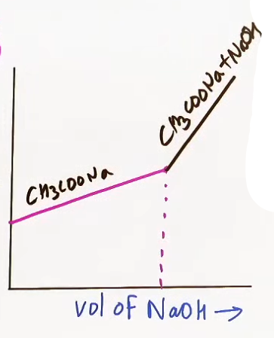
* The "Jump" Mechanism: H⁺ and OH⁻ conductances are significantly higher than all other ions because they do not just "travel"; they "jump" through the water's hydrogen-bonded network (Grotthuss mechanism).
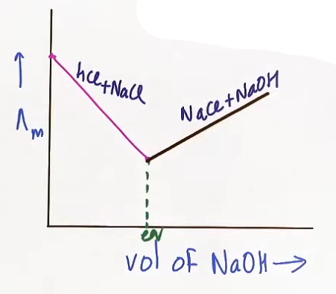
* Case 1: Strong Acid vs. Strong Base (HCl vs. NaOH):
* Before Equivalence: H⁺ ions are replaced by Na⁺ ions. Since H⁺ is faster, “conductance drops”.
* After Equivalence: Excess OH⁻ is added. Since OH⁻ is very fast, “conductance rises sharply”.
@ photo – conductometric1.png

* Case 2: Weak Acid vs. Strong Base (CH₃COOH vs. NaOH):
* Before Equivalence: Weakly dissociated acid is replaced by a strongly dissociated salt (CH₃COONa). “Conductance rises”.
* After Equivalence: Excess OH⁻ causes a “sharp rise”.
@ photo - conductometric2.png
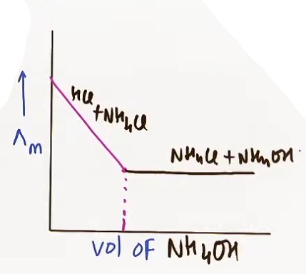
* Case 3: Strong Acid vs. Weak Base (HCl vs. NH₄OH):
* Before Equivalence: H⁺ is replaced by NH₄⁺. “Conductance drops”.
* After Equivalence: Excess NH₄OH is added. However, the “Common Ion Effect” from NH₄Cl suppresses the dissociation of NH₄OH. Conductance remains “almost constant”.
@ photo - conductometric3.png

---

ALL IMPORTANT FORMULAS
Formula | Context | Meaning of Variables
Λᵒₘ = xΛᵒₘ{+} + yΛᵒₘ{-} | Kohlrausch's Law | x, y: Stoichiometric coefficients of ions.
∝ = Λₘ / Λᵒₘ | Weak Electrolytes | ∝: Degree of dissociation.
K = (C Λₘ^2)/[Λᵒₘ (Λᵒₘ - Λₘ)] | Dissociation Constant | Derived by substituting ∝ into K = C∝²/(1-∝).
S = κ(1000)/Λᵒₘ | Solubility | S: Solubility in mol/L; κ: Specific conductance.

---
JEE ADVANCED INSIGHTS
* Specific Conductance vs. Molar Conductance Dilution: κ always decreases on dilution (fewer ions per mL), but Λₘ always increases (volume containing 1 mole increases more than κ decreases).
* Grotthuss Mechanism: This explains the "anomalous" high mobility of H⁺ and OH⁻, which is the foundation of all titration curve shapes.
* Common Ion Suppression: In the SA-WB titration (HCl + NH₄OH), the curve does not rise after the equivalence point because the salt formed (NH₄Cl) provides a common ion that prevents the weak base from dissociating.
---
PROBLEM-SOLVING FRAMEWORK

Type 1: Calculating Weak Electrolyte Λᵒₘ
1. Identify the Target: Usually a weak acid (HA) or base (BOH).
2. The "Add/Subtract" Rule: Find three strong electrolytes that contain the ions of the target.
3. Equation: Λᵒₘ_{HA} = Λᵒₘ_{NaA} + Λᵒₘ_{HCl} - Λᵒₘ_{NaCl}.

Type 2: Identifying Titration Graphs
1. Check Start: High conductance = Strong Acid; Low = Weak Acid.
2. Check Equivalence: Falling = H⁺ is being removed; Rising = Salt is forming.
3. Check End: Sharp Rise = Strong Base (OH⁻); Constant = Weak Base (Common ion effect).
PYQ-STYLE THINKING
* The "Same Cell" Trap: JEE often gives resistance of one solution to find the Cell Constant (G*), then asks for the conductivity of a second solution using the same cell. G* is constant for a given cell.
* Unit Conversion: JEE Advanced often asks for units of the Onsager slope (b). Remember: [b] = [Λₘ]/[√C].
* Infinitely Diluted Change: Adding more water to an already "infinitely diluted" solution causes “no change” in molar conductivity.

---
IMPORTANT RESULTS TO MEMORIZE
* Mobility Order: H⁺ > OH⁻ > all other ions.
* Hydration Effect: Smaller ions in the periodic table (Li⁺) have larger hydrated radii and “lower” conductance than larger ions (K⁺).
* Molar vs. Equivalent: Λₘ = Λₑq x n-factor.
---
COMMON MISTAKES
* Stoichiometry in Kohlrausch: Forgetting to multiply Λᵒₘ by 2 or 3 (e.g., Λᵒₘ_{MgCl₂} = Λᵒₘ_{Mg²⁺} + 2Λᵒₘ_{Cl⁻}).
* Conductivity vs. Conductance: Confusing κ (property of 1 mL) with Λₘ (property of 1 mole).
* Weak vs. Strong Curves: Misidentifying A (weak) and B (strong) on the Λₘ vs √C plot.
---

REVISION NOTES (ULTRA-SHORT)
* Kohlrausch: Λᵒₘ is the sum of independent ionic parts.
* ∝: Ratio of current Λₘ to limiting Λᵒₘ.
* Titrations: H⁺/OH⁻ are fastest; replacement of H⁺ causes a drop; addition of OH⁻ causes a sharp rise.
* Dilution: κ ↓ (ions/vol ↓); Λₘ ↑ (dissociation/vol ↑).

--------------------------------------------------------------------------------
CHAPTER OVERVIEW: APPLIED ELECTROCHEMISTRY
* Core Idea: Transitioning from theoretical redox reactions to practical applications where chemical energy is stored (Batteries), converted continuously (Fuel Cells), or causes material degradation (Corrosion).
* Important Subtopics:
* Primary Cells: Non-rechargeable (Dry Cell, Mercury Cell).
* Secondary Cells: Rechargeable (Lead Storage, Ni-Cd).
* Fuel Cells: Continuous energy production.
* Corrosion: Mechanisms and prevention of rusting.
* Weightage Relevance: High for JEE Main (frequent memory-based questions on reactions and uses) and conceptual for JEE Advanced (linking Nernst equation to fuel cell pressures).
* Prerequisites: Basic understanding of Anodes (Oxidation) and Cathodes (Reduction) in Galvanic cells.
---
THEORY NOTES (PRACTICAL CELLS & CORROSION)
A. Primary Cells (Non-Rechargeable)
These cells become "dead" once the reactants are exhausted as the reaction cannot be reversed.
1. Dry Cell (Leclanché Cell):
* Anode: Zinc container (Zn → Zn²⁺ + 2e⁻).
* Cathode: Carbon (Graphite) rod surrounded by powdered MnO₂ and carbon.
* Electrolyte: Moist paste of NH₄Cl and ZnCl₂.
* Cathode Reaction: MnO₂ + NH₄⁺ + e⁻ → MnO(OH) + NH₃.
* Note: The NH₃ produced is complexed by Zn²⁺ to prevent pressure buildup ([Zn(NH₃)₄]²⁺).
* Output: ~1.5 V.
# net reaction : Zn + 2MnO₂ + 2NH4⁺ → Zn²⁺ + Mn₂O₃ + 2NH₃ + H₂O
& Zn²⁺ + 4NH₃ → [Zn(NH3)4]²⁺
# Zinc can corrode so leakage problem.
# Low cost and easily available.
2. Mercury Cell (Button Cell):
* Anode: Zinc-Mercury amalgam. (Zn hi hai vaise toh)
Rexn : Zn + 2OH⁻¹ → ZnO + H₂O + 2e⁻
* Cathode: Paste of HgO and carbon.
Rexn : HgO + H₂O + 2e⁻ → Hg + 2OH⁻¹
* Electrolyte: Paste of KOH, NaOH and ZnO.
* Net Reaction: Zn(Hg) + HgO(s) → ZnO(s) + Hg(liq.).
* Crucial Advantage: It provides a “constant voltage (1.35 V” throughout its life because the net reaction involves no ions in solution whose concentration could change.
# Long life, stable output
# Less effect of temperature change
## Environment issue: Mercury is toxic
B. Secondary Cells (Rechargeable)
1. Lead Storage Battery:
* Anode: Spongy Lead (Pb).
Rexn : Pb + SO₄²⁻ → PbSO₄ + 2e⁻
* Cathode: Grid of lead packed with Lead Dioxide (PbO₂).
Rexn : PbO₂ + 4H⁺ + SO₄²⁻ + 2e⁻ → PbSO₄ + 2H₂O
* Electrolyte: ~38% solution of Sulphuric acid (H₂SO₄).
Net Rexn : Pb + PbO₂ + 2H₂SO₄ → 2PbSO₄ + 2H₂O
* Discharging Reactions: Pb and PbO₂ both convert to PbSO₄.
* Charging: Reverses the reactions using an external EMF, restoring Pb and PbO₂ and increasing the density of H₂SO₄.
# If concentration of H₂SO₄ falls below a 1.2 g/ml charging is required.
# Output *per cell* ~2.0V
# Heavy weight due to lead plates
# High current output
2. Nickel-Cadmium (Ni-Cd) Cell:
* Anode: Cadmium(Cd).
Rexn : Cd + 2OH⁻ → Cd(OH)2 + 2e⁻
* Cathode: Nickel Oxyhydroxide (NiO(OH)).
Rexn : 2NiO(OH) + 2H₂O + 2e⁻ → 2Ni(OH)2 + 2OH⁻
* Electrolyte: Conc. KOH
seperator : Nylon/porous polymer sheet
* Net Discharge Reaction: Cd(s) + 2NiOOH(s) + 2H₂O(l) → Cd(OH)₂(s) + 2Ni(OH)₂(s).
* Feature: Longer life than lead batteries but more expensive; used in medical instruments and emergency lights.
# since electrolyte is not consumed, so long life
# Output ~ 1.2V
## Environmental issue : Cadmium is toxic
# Temperature resistant
C. Fuel Cells
* Definition: Galvanic cells designed to convert the energy of combustion of fuels (like H₂, CH₄, CH₃OH) directly into electrical energy.
* Hydrogen-Oxygen Fuel Cell:
* Anode: Porous Pt or Ni electrode(H₂ supply).
* Cathode: Porous Pt or Ni electrode(O₂ supply).
* Fuel: H₂
* Oxidant: O₂
* Electrolyte: H₂SO₄ (acidic fuel cell), KOH (alkaline fuel cell).
In acidic medium-
H₂ oxidises and O₂ reduces.
net reaction : H₂ + (1/2)O₂ → H₂O
In basic medium-
H₂+ 2OH⁻ → 2H₂O + 2e⁻
(1/2)O₂ + H₂O + 2e⁻ → 2OH⁻
same net reaction
* Efficiency: ~70% (compared to ~40% for thermal plants).
* Product: Pure water (used by astronauts in the Apollo mission).
# constant current till H₂, O₂ supply
# No pollution, eco friendly
# E_cell can be managed by adjustion pressures ofH₂and O2
D. Corrosion
* Mechanism: An electrochemical process occurring on metal surfaces.
* Anode: Iron oxidizes (Fe → Fe²⁺ + 2e⁻).
* Cathode: Oxygen reduces in the presence of H⁺ (from CO₂ + H₂O).
* Rust: Fe²⁺ is further oxidized by air to Fe³⁺, forming hydrated ferric oxide (Fe₂O₃⋅xH₂O).
* Prevention:
* Barrier Protection: Painting, oiling, or non-corroding metal coating.
* Sacrificial Protection (Galvanization): Coating iron with Zinc; Zinc oxidizes first because it has a higher oxidation potential.
* Cathodic Protection: Connecting iron to a more active metal (Mg or Zn) which acts as the anode.

---
ALL IMPORTANT FORMULAS
Application | Key Concept/Formula | Meaning
Fuel Cell | E_cell = E° − (RT/nF) × ln[1 / (P{H₂} × √P{O₂})] | Potential can be managed by gas pressures.
Battery Efficiency | η = (ΔG / ΔH) × 100 | Efficiency of energy conversion.
Lead Battery | Density of H₂SO₄ < 1.2 g/mL | Trigger point for recharging.

---
JEE ADVANCED INSIGHTS
* Constant Voltage Intuition: In the Mercury cell, since the net reaction is Zn + HgO → ZnO + Hg, no ions appear in the expression for Q in the Nernst equation. Thus, E_{cell} ≅ Eᵒ_{cell} throughout its operation.
* Ammonia in Dry Cells: Ammonia gas produced at the cathode would normally cause the cell to explode; Zn²⁺ acts as a "safety valve" by complexing it into a solid/liquid state [Zn(NH₃)₄]²⁺.
* Alkaline Anti-rust: Alkaline solutions (phosphates/chromates) prevent rusting by reducing the availability of H⁺ ions required for oxygen reduction at the cathode.
---
IMPORTANT RESULTS TO MEMORIZE
* Mercury Cell: 1.35 V (Constant).
* Dry Cell: 1.5 V.
* Ni-Cd Cell: 1.2 V.
* Lead Storage: 2 V per cell (usually 12 V total in cars).
* Rust Formula: Fe₂O₃ ⋅ xH₂O.

---
COMMON MISTAKES
* Confusing Secondary vs. Primary: Thinking Dry cells can be recharged.
* Rust Anode/Cathode: Swapping the roles; remember Iron itself is the Anode (Fe → Fe²⁺).
* Fuel Cell Efficiency: Assuming 100% efficiency; it is high (~70%) but not perfect.
---
REVISION NOTES (ULTRA-SHORT)
* Primary: Dry (1.5V, Mn +4 to +3); Mercury (1.35V, Constant).
* Secondary: Lead (Pb/PbO₂, uses H₂SO₄); Ni-Cd (Longer life).
* Fuel Cells: Continuous fuel input; Space use; High efficiency.
* Corrosion: Fe as Anode; O₂ as Cathode; Zn as sacrificial coating (Galvanization).

---------------------------------------
latimar diagram
# jis metal ka oxidation potential jitna high uske salts ki thermal stability utni jyada

